Assignment 8

Group 16

November 15, 2019

Figure 1: Male vs. Female  
Male has higher median Levenshtein distance than female with same native language. Male shows more values with Levenshtein distances 2 or more.

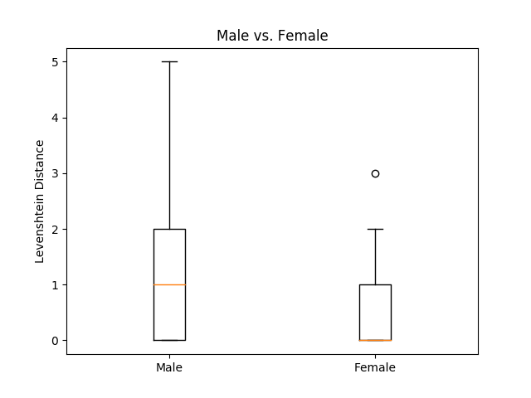

Figure 2: English vs. Bengali

Bengali and English have similar medians, but Bengali shows fewer results with distance 0, and more outliers.

